***Team 01-07***

***Team Members:***

***Jm Tameta, Matt Sacco, Matt Shea, Meghan McConnell, Sarah Phung, Val Roberts***

***ACC 311/CSC 315***

***Energy Demand***

***(IIa) Project Proposal & Specifications***

***Problem***

Currently The College of New Jersey does not have a centralized database that provides information regarding the energy consumption of all buildings on campus. In addition there does not exist a user-friendly web application associated with said database; therefore one must search through multiple excel sheets to find and analyze the data they need. Furthermore due to the lack of a database, visualization tools such as graphs and infographics are not readily available.

***Proposed Solution***

In order to address the problem stated above our team will first design, develop, and implement a centralized database to input and search all existing data regarding the energy consumption of all buildings on campus. Initially we are going to focus on residential halls since there are less residential halls than academic buildings. Additionally we plan to design a user-friendly web application to access the database. More specifically we plan to integrate different filters to give users control when looking for information regarding specific buildings. We are aware that users will want to compare and view different building datasets therefore we will dynamically create and integrate visual infographics and graphs. We are aware of the college’s Greener Going Forward Sustainability Plan therefore we are hoping to provide a total amount of carbon equivalent emissions from each residential building.

***Existing Solution***

At the moment a centralized building energy demands database does not exist, therefore we are referencing other resources such as the TCNJ Covid and Kibana user interface dashboards. We are also considering ecommerce websites where users are able filter their view of the company’s products.

***Research & Data Collection***

We plan to build a centralized database that makes all the data regarding the demand of energy at the college easy to read. Different filters will be added so that data relating to specific buildings can be displayed. For example, if one wishes to look at energy demand in relation to residence halls or science buildings on campus, a filter can be applied. In order to create this database, we will need to collect further data. Information about each specific building is necessary, such as square footage, energy demand, units of energy and cost associated to power each building. Our group plans to utilize the data given to us for this project. However, we have also requested more data if available. In order to analyze energy consumptions and the costs associated, we will need to do further research to collect more data. First, we will need to figure out the current distribution of energy throughout different buildings on campus. If the data is available, we would like to know how much it costs for each building to be powered. If this data is not available, we will be able to estimate based on the total energy consumption at the college and allocate specific costs to each building based on other information given, such as square footage. Other data that will be helpful could be a breakdown of the types of energy used on campus and the costs associated with them. We have reached out to Mr. Romano, as well as the college to see if this data is available for us to analyze.

***Software Specific***

Possible other applications of the system (how it could be modified and reused.)

* + The application can be reused for other recurring costs for each of the buildings, such as water and other resource usage.
  + Resource consumption by building as a calculator can be refitted to be any resource by any other additional unit as a way to gauge what changes to external, overarching units need to be done in order to maximize efficiency.
* Performance – specify how and to what extent you will address this.
  + We will utilize a database containing administrator-placed data that interfaces with a web page.
  + Graphics and graphs will be generated dynamically using user-created filters.
* Security - specify how and to what extent you will provide security features
  + User authentication, two different types of profiles in order to help compartmentalize different user access abilities.
    - An administrator account that is able to update the database with new information.
    - A basic user account that is only able to view the profile.
* Backup and recovery – specify how and to what extent you will implement this
  + Recovery of previous versions of the tool can be done through version control via GitHub.
* Technologies and database concepts the team will need to learn, and a plan for learning these
  + The MVR model and displaying information.
  + Setting up a stack for a web based application utilizing said database.
  + Population of database with cleaned data.

***Diagrams***

1. A diagrammatic representation of the system boundary that specifies what data you will model and which queries you will implement 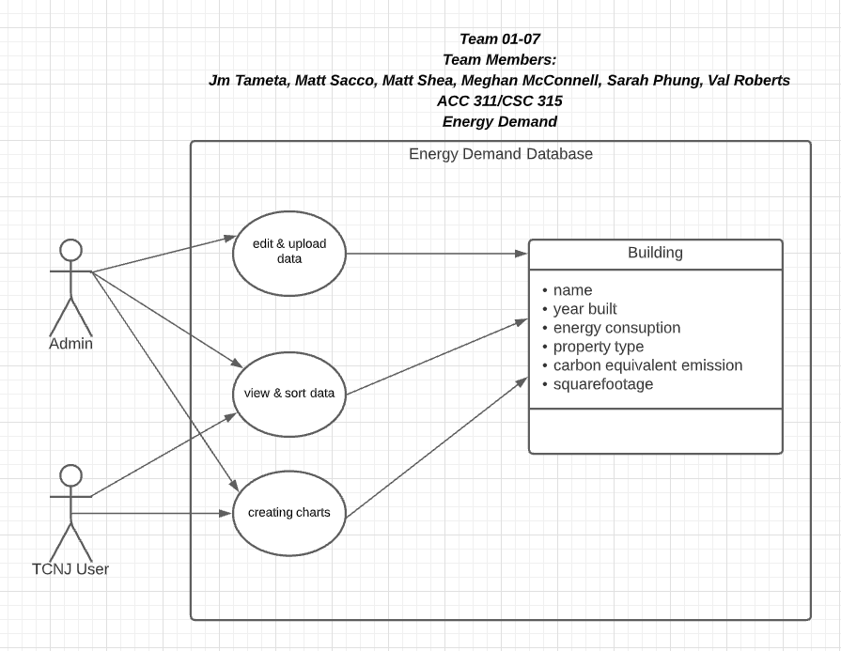
2. 1-page quad chart 